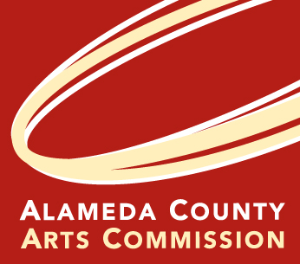
ALAMEDA COUNTY ARTS COMMISSION
1106 Madison Street, Suite 336, Oakland, CA 94607
www.acgov.org/arts | artscommission@acgov.org | office phone 510-208-9646
Rachel Osajima, Director | direct phone 510-271-5162

2021 ARTSFUND Grants Program
Grant Period: July 1, 2021 – June 30, 2023

final report form Due DATE: July 30, 2023

Date Grant Award Amount $
Organization Name
Mailing Address
Contact Person Title
Phone Email Address Website
Please complete all sections of this form and return it to Alameda County Arts Commission by the deadline. Please use the space provided. No supporting documents should be submitted. A digital version of this form is available on the Arts Commission website at www.acgov.org/arts - click on Programs and ARTSFUND. You may submit this form by mail or email to rachel.osajima@acgov.org

1. Provide a brief description of approved grant-funded general operating and/or programming. Briefly describe any changes in your general operating and/or program(s) since the application was submitted. (Answer in the space provided below.)

2. Was your organization able to achieve the goals it originally intended for this grant? If all the goals were not achieved, please explain why.

3. Approximately how many people were directly reached by this program?

4. OPTIONAL: Please feel free to convey any other information about your organization and/or the ARTSFUND Grant Program.

CERTIFICATION (This must be signed by someone legally authorized to represent your organization):
I certify that we have fulfilled the terms and conditions of this grant as stated in the ARTSFUND Terms and Conditions of Award and that the information included in this final report is correct and accurate.

SIGNATURE DATE PRINTED NAME TITLE

